# Level Design

Mechanics:

* Get to the objective which is a door.
* The player will have 3 random card selections of what objects they can spawn into the game world. Click one of the cards you want to spawn and click on the area you want it to instantiate, it has to be around a specified area such as the ground or on top of another spawned object. These objects are used to kill or trap an enemy, and get to the objective.
* The door in some levels is in high positions, you can use the objects to climb up to the door.
* The player can jump.
* The player’s objective is to get to the door.
* The randomised objects are used to get to the door, or to kill enemies etc.
* The 3 random objects have to be spawned in order to randomise more.

## Level Goals:

Each level the objective is very simple. Get to the door, similar to water boy and laver girl, some levels enemies will be pre spawned as others won’t.

Simple Sketch of how the gameplay will be/look. Bottom of screen is the 3 random card selections of objects you can use.

## Sketch Ideas:

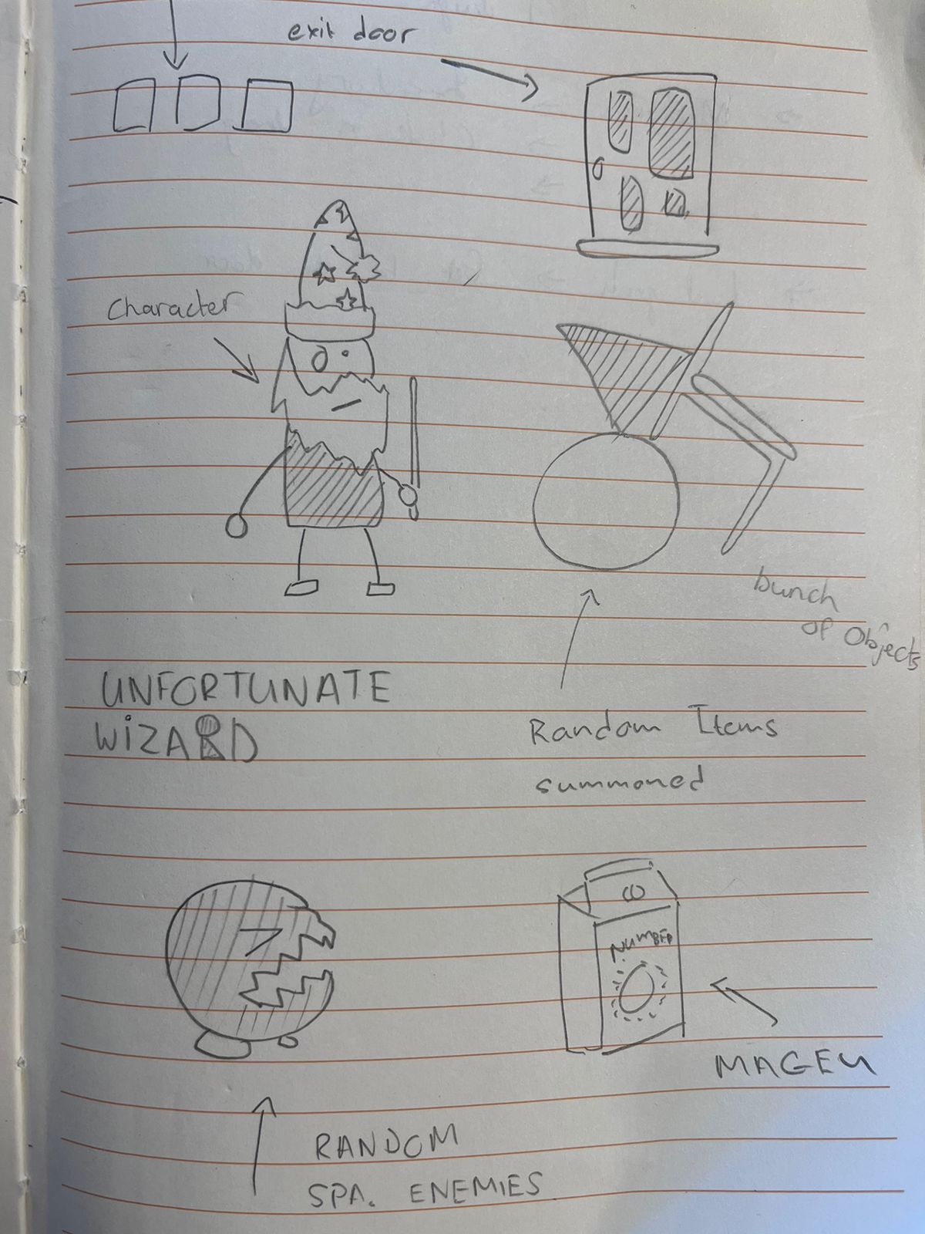

This sketch idea is of the character and, things you can spawn within the game. The items vary from a chair, ball, enemies, bottle of milk etc.

At the top left of the screen, are your three objects you can click and drag into the world.